Title of the presentation of My Work Title
Author’s Name FAMILY-NAME
Affiliation (university, company), your@email.org

Abstract
Describe the contents of your article in a maximum of 250 words.
The finished articles should use this template, and have a minimum extension of 4 pages and a maximum extension of 13 pages (including the title and abstract page)
Articles can be written in English, Spanish and Catalan. Los artículos pueden ser escritos en inglés, castellano o catalán, pero damos las normas en inglés.

Biography
Give your biography with a maximum of 250 words.

Introduction
Make a general introduction to the work or works you are presenting. It can describe the intention, the context of the company, the original idea, etc.

Choreography and movement: from dancers to postproduction
Please make a separate section dedicated to the specific topic of the choreography/movement on screen, how you conceived the danced movement and the recording of it, and also the editing used for enhancing/modifying/creating the screen choreography.
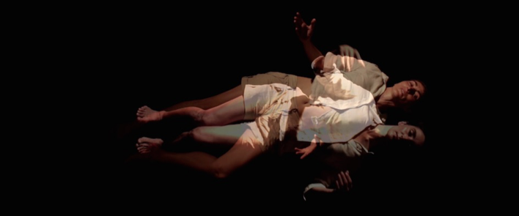
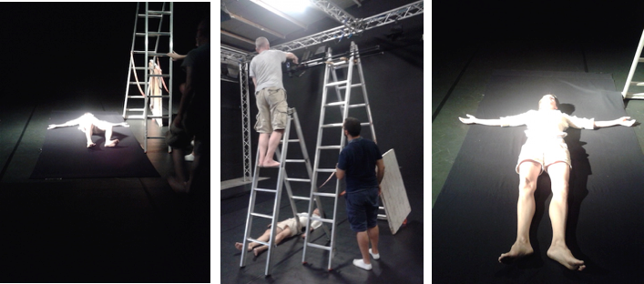
Fig.1 Scaffolding and camera position for the recording of Visiones de Santa Teresa de Avila
Fig.2 An example of superposition in Visiones de Santa Teresa de Avila
Please include as many pictures as possible of your work and the creative process or making of as we can see in figure 1. All the images/figures must have a caption, and be
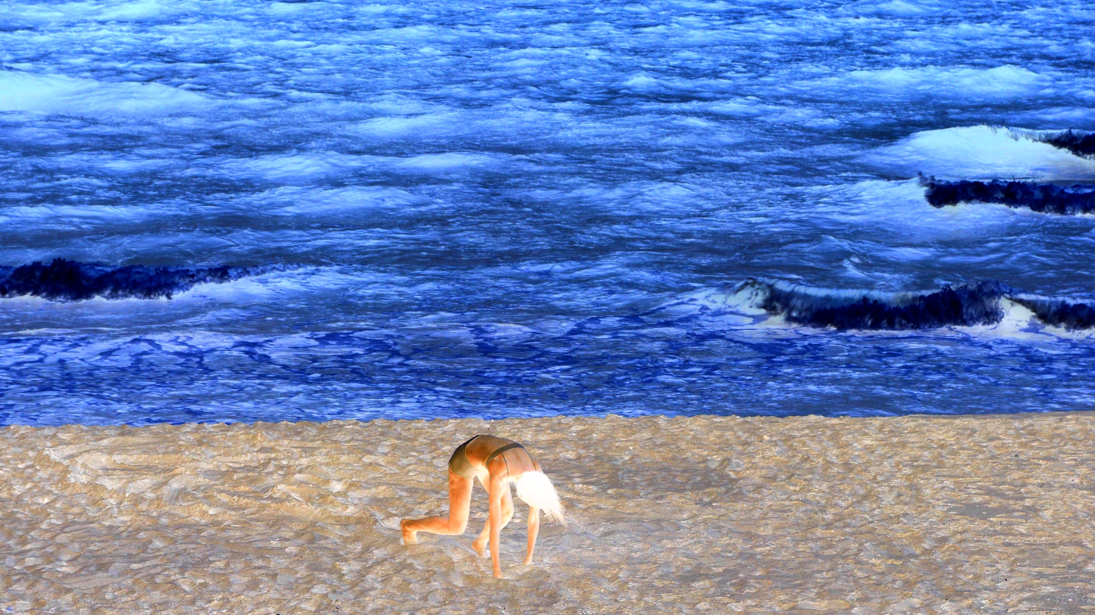
Fig.3 An example of a full width image from a rehearsal with Lorenza di Calogero.
numbered as shown (Fig.1, Fig.2 …). All figures must be referenced in the text (as we can see in figure 2…).
As it is your work, we would like to have interesting and meaningful pictures that illustrate your article. You can add images from works of other authors that you want to reference, as Spanish law allows citation of graphic materials for academic purposes.

Other items
Please develop any idea or element of your screendance that is relevant.

Sub-sections
You can introduce sections and subsections in your text. Please follow the paragraph styles in this document. Copy the sections and subsections, headings and figure captions as needed.
Please introduce high quality pictures of your work, and if you see fit, you can use the full width of the paper as shown in figure 3.

Citations and references

Citation in the text
We will use the APA style unless we specify otherwise. All the written documents like books, articles, web pages, etc. are cited using the family name of the author followed by the year of publication (Martínez, 2007), and when citing a particular part of the text, the page number (Martínez, 2007, p. 27). For two up to 5 authors, the family names are separated by commas and an ampersand at the end (Wink & Killingsworth, 2011), (Herrera, Herrera-Viedma, Alonso, & Cabrerizo, 2009, p. 560). For more than six authors the first author is mentioned followed by et al. (Barber et al., 2008).

References
There must be a references section with all the works cited in the text. References will be divided into bibliography and filmography, when you cite specific films or video-dance works.
All the works are listed by first author’s family name, alphabetically.
The videodance or screendance works will be also listed and referenced by director’s name. Please indicate the director’s name (Donen, 1951) and the choreographer’s (De Mey, 2009) when available, see the references below for example. Indicate the country, the title and the duration and if available, an online link for viewing.

Conclusions
Indicate your conclusions.

Acknowledgements
You can thank here the institutions or persons that have made possible your work or article.

References

Bibliography
Arencibia-Jorge, R., Leydesdorff, L., Chinchilla-Rodríguez, Z., Rousseau, R., & Paris, S. W. (2009). Retrieval of very large numbers of items in the Web of Science: an exercise to develop accurate search strategies. El Profesional de la Información, 18(5), 529-533.
Barber, E., Pisano, S., Romagnoli, S., Parsiale, V., De Pedro, G., & Gregui, C. (2008). Los catálogos en línea de acceso público del Mercosur disponibles en entorno web. Información, Cultura y Sociedad, (18), 37-55.
Beall, J. (2011). Academic Library Databases and the Problem of Word-Sense Ambiguity. The Journal of Academic Librarianship, 37(1), 64-69. doi:10.1016/j.acalib.2010.10.008
Herrera, F., Herrera-Viedma, E., Alonso, S., & Cabrerizo, F.J. (2009). Agregación de índices bibliométricos para evaluar la producción científica de los investigadores. El Profesional de la Información, 18(5), 559-561.
Hull, D., Pettifer, S. R., & Kell, D. B. (2008). Defrosting the digital library: bibliographic tools for the next generation web. PLoS Computational Biology, 4(10), e1000204. doi:10.1371/journal.pcbi.1000204
Martínez, R. (2007). Biblioteca Digital: conceptos, recursos y estándares. Buenos Aires: Alfagrama.
Wink, D. M., & Killingsworth, E. K. (2011). Optimizing use of library technology. Nurse Educator, 36(2), 48-51.

Filmography
Anderson, David (Direction) & Miller, Preston (Choreography) (2013). Enemy within [Screendance]. USA. 18m. https://www.youtube.com/watch?v=M3ZxD8kFh2U
Alkan, Özgür Can (Direction) & Azazi, Ziya (Choreography) (2015). Circle [Screendance]. Turquía. 4m24. https://youtu.be/m097xBDsoeo
De Mey, Thierry (Direction) & Keersmaeker, Anne Teresa (Choreography) (2009). Prélude à la mer. [Screendance]. Belgium. http://www.numeridanse.tv/en/video/352_prelude-a-la-mer
Donen, Stanley (Direction) (1951). Royal Wedding (Bodas reales) [Motion Picture]. USA: MGM. 1h33m.

